**Laboratory work No. 4. Working with the menu**

1. Create a project:

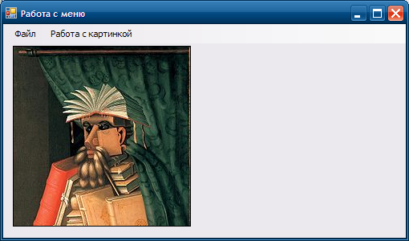

1. in the menuStrip, enter the following: Place the

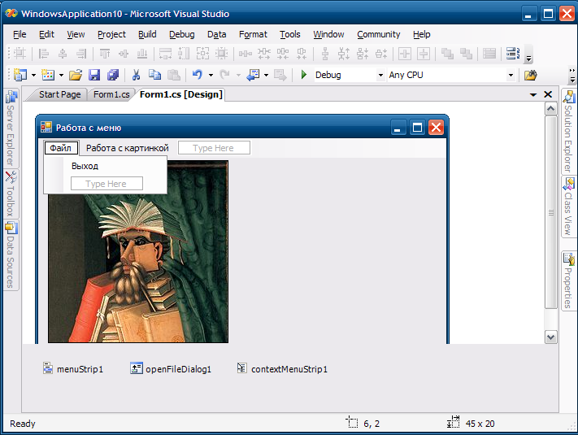

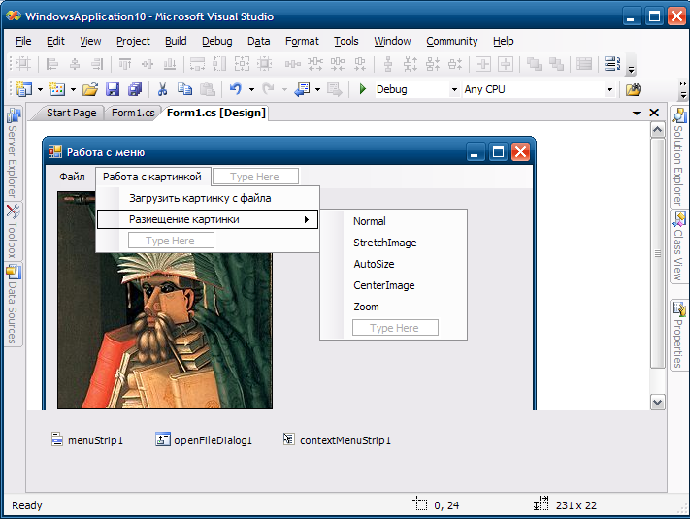

1. openFileDialog component on the form (it is not visual) 

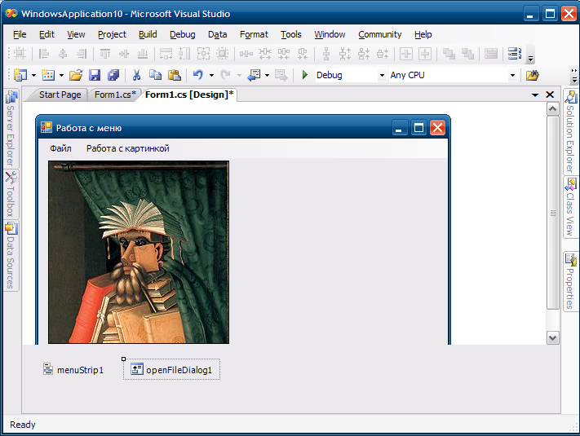

1. Then, on each submenu, create a Click event

private void exit ToolStripMenuItem_Click (object sender, EventArgs e)

{

//Application.Exit (); // or here we use the class and the Exit method to exit the program

this.Close (); // in this line we close this form objectloadPictureSFile ToolStripMenuItem_Click

}

private void(object sender, EventArgs e)

{

if (openFileDialog1.ShowDialog () = = DialogResult.OK)

/ * in the condition for checks when the dialog box was opened, the Open button was pressed then load the picture, if the cancel button was pressed, the picture does not load * /

{

pictureBox1.Image = Image.FromFile (openFileDialog1.FileName);

// load an image from a file.

}

}

// then we set the properties of the picture, its position relative to the frame of our component and the real size of the picture

private void normalToolStripMenuItem_Click (object sender, EventArgs e)

{

pictureBox1.SizeMode = PictureBoxSizeMode.Normal;

}

private void stretchImageToolStripMenuItem_Click (object sender, EventArgs e)

{

pictureBox1.SizeMode = PictureBoxSizeMode.StretchImage;

}

private void autoSizeToolStripMenuItem_Click (object sender, EventArgs e)

{

pictureBox1.SizeMode = PictureBoxSizeMode.AutoSize;

}

private void centerImageToolStripMenuItem_Click (object sender, EventArgs e)

{

pictureBox1.SizeMode = PictureBoxSizeMode.CenterImage;

}

private void zoomToolStripMenuItem_Click (object sender, EventArgs e)

{

pictureBox1.SizeMode = PictureBoxSizeMode.Zoom;

}

1. Now add to our form

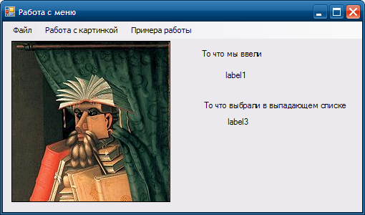

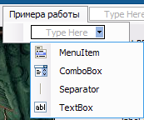 

1. A list of which components we can use drops out; first we select TextBox, Separator, ComboBox.

Create a handler for the TextChanged event on the TextBox in our menu

private void toolStripTextBox1_TextChanged (object sender, EventArgs e)

{

label1.Text = toolStripTextBox1.Text;

}

On the ComboBox toolStripComboBox1_SelectedIndexChanged

private void toolStripComboBox1_SelectedIndexChanged (object sender, EventArgs e)

{

label3.Text = toolStripComboBox1.SelectedItem.ToString ();

}